**REQUIREMENT ANALYSIS IN CUSTOMER SEGMENTATION (AIRTEL)**

**Definition: Customer segmentation** in the telecom industry is the process of dividing a customer base into groups with similar characteristics, such as usage habits, demographics, or behavioural patterns. This allows telecom companies to better understand their customers and tailor their marketing and communication strategies to each group.

Here I am going to explain in details about AIRTEL some ways Airtel has used segmentation and other strategies:

* **Rural call centres**

Airtel has established call centres in rural areas to communicate with customers in their local languages.

* **Outbound call centres**

Airtel has set up call centres in cities like Guwahati, Kochi, Siliguri, and Bhubaneswar to offer assistance in regional languages.

* **New plan segmentation**

Airtel has created a platinum plan for customers who want higher-end services.

* **Digital services**

Airtel is looking to tap into the education and healthcare sectors through its digital services.

* **Content partnerships**

Airtel is partnering with other companies to provide content.

BUSINESS OBJECTIVES OF CUSTOMER SEGMENTATION: -

* Churn reduction: Understand the actual customers requirements as per the Churn reduction is concern and address the exceptional service to minimise or eradicate the Churn.
* Customized pricing: Create customized pricing models for different segments of users.
* Service expansion: Identify unexplored market and penetrate the service.
* Aligning growth strategy with consumer needs: Develop strategies based on the changing needs of different customer segments.
* Enhanced customer experience and sales: pointing out the exact need of customer and provide utmost service experience by generating maximum sales.
* Improved customer relationships and brand loyalty: connecting with the customers at timely interval through different messages or social media to establish the brand loyalty.

Customer segmentation can be based on a variety of factors, such as usage patterns, spending, geographic, revenue, products, services, demographics, and behaviour etc.

STAKE HOLDERS: - They are the Client (company management personals anyone who is directly associated in the process), product manager, developers, testers etc. we have to make a link between the client and the developers to make process of understanding smooth and clear without any ambiguity.

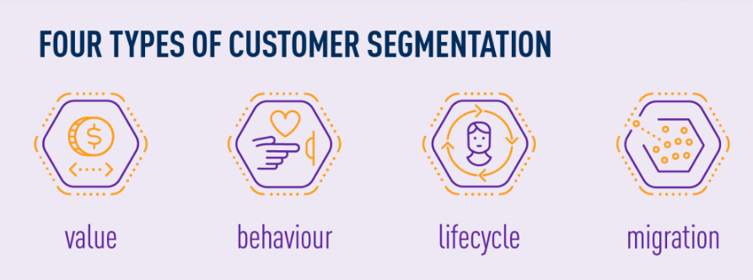

**Customer Value Segmentation**

Customer loyalty has been termed the most crucial aspect of marketing. The main reason is the 80/20 marketing costs rule, which says, “top 20% profitable customers contribute 80% of a company’s profits and 80% of a company’s costs are contributed by top 20% of unprofitable customers”. Therefore, companies invest significant time and effort to retain customers. Telecom companies incline themselves to segment profitable customers by calculating their value.

The crucial steps involved in customer value segmentation are:

* Calculate the customer value measure for every customer (this is the summary of past and predicted future value of customers),
* Use decile analysis that divides the entire customer base into ten equal-sized groups, also known as deciles,
* Describe customer profiles to monitor their needs carefully and develop a relevant marketing strategy that answers their needs.

**Customer Behaviour Segmentation**

Over the past years, the number of people using telecom services has drastically increased. To manage such massive amounts of customers and understand their needs, telecommunication companies capture every action performed by customers, building huge repositories containing customers’ behavioural data. As telecom services are used extensively by people in their daily lives, telecom companies are tapping into determining customer needs and developing relevant strategies from the collected customer behavioural data. The usage of customer behavioural data in market segmentation is termed customer behavioural segmentation.

**Customer Lifecycle Segmentation**

To compete in the market, modern-age telecom companies need to retain customer-centric market segmentation techniques. Understanding customer behaviour and improving customer loyalty play a fundamental role in determining the success of the chosen market segmentation technique. Customer lifecycle segmentation considers a snapshot of the current life stage of customers and performs market segmentation by analysing their needs and interests.

As time passes, people change their social roles. Therefore, it is important to identify and understand the current social roles of customers. There are two types of customer life stages in this type of segmentation: stages related to their customers’ association with the company and stages of their individual lives. Regardless, the premise of this segmentation technique lies in segmenting the varying customer behaviour exhibited at different life stages.

### Customer Migration Segmentation

Due to the increased competition in the telecommunications industry, telecom companies are experiencing a high customer churn rate. Such high levels of customer attrition have negative impacts on various aspects of a telecom company. Some impacts include loss of average revenue per customer, decreasing sales and profit, and difficulty acquiring new customers. Owing to these reasons, modern telecom companies incline themselves to understand and analyse the plausible factors that cause customer defection. This has led to the growing importance of customer migration behaviour.

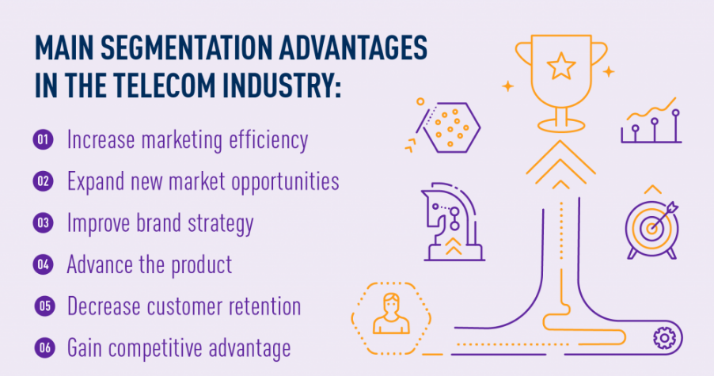

### Better brand strategy

Once the key customers’ motivators are identified, products can be branded appropriately. The goal of market segmentation is not only to reach the targeted audience but also to see the true value of the company thanks to the marketing that speaks to them. Promoting the product with a well-adjusted brand strategy allows for putting the company’s head above competitors.

### Improving the product

Knowing who wants to buy the product and what their needs help differentiate the company as the best solution on the market. The result of such practice will be increased satisfaction and better performance against competitors. The benefits also extend beyond core product offerings since any insights allow companies to offer better customer support, professional services, and any services that guarantee a complete customer experience.

### Lower customer retention

Thanks to customer segmentation, marketers can identify customers who require extra attention, those that churn quickly, and those with the highest potential value. It can also help create targeted strategies that capture customers’ attention and create positive, high-value experiences with the company.

### Competitive advantage

With the amount of competition in the telecom sector, the combination of market segmentation techniques can ensure revenue streams. For instance, by combining geographical segmentation and behavioural segmentation, companies can gain insights into the customers’ behavioural trends located at different geographical locations.

FUNCTIONAL & NON-FUNCTIONAL REQUIREMENT

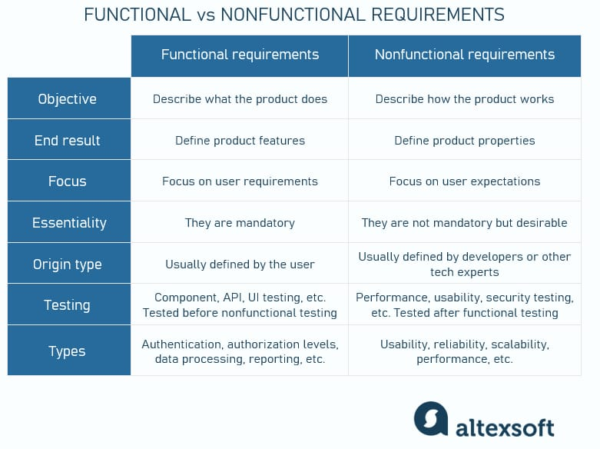

FUNCTIONAL REQUIREMENT: -

Data Collection: - different modes of data collection is required.

Billing Interface: - collection of customers billing data are very crucial in understanding the customer purchasing behaviour.

Customer Profile: - fetch customers profile from different survey, interview, and other question answer methodology.

Digital media: - we can get large chunk of customers data from different digital platform

Data integration: - alignment of raw data into a structural form.

SEGMENTATION CRITERIA: -

Demographic: -customer data as per age, sex, income, education etc in different segment.

Usage: - customers data as per the usage patterns (Calls, internet, messages etc) in different segment.

Geographic: - customers data per the culture and customs in different geographic areas.

Revenue: - customer data as per the volume of revenue flow.

Customer loyalty: - customer data as per the loyalty and endurance.

Promotional schemes: customer data as per the new updated promotional schemes.

NON-FUNCTIONAL REQUIREMENTS: - It deals with the non-functional attributes of the service like performance, reliability, scalability, security, compliance, availability, integrity, legal and regulatory requirements etc. Customer segmentation base on above attributes varies and based on that data integration is indispensable.

Data Requirements and Documentation: - Based on the function and non-functional requirements all data are collected as different data types and sources. All required data are documented and share to the client for the validation and verification for the real time understanding as per the guidelines.

Tools and Analysis: - All data are measured in different analytical tools (Power BI, Tablu ect) and presented to the Clients for the real time understanding.

Prioritisation and Negotiation: - Prioritisation and Negotiation are to be done based with clients on the critical requirements, resources and their feasibility.

Risk Management:- it is important to mitigate threat to the company business. Some common risks are like cyber-attack, regulatory changes, natural disaster, competitor, data protection, governance etc.

Communication and Collaboration:- Effective communication with the stakeholders and tech team helps to develop shared vision of the project.

Traceability and Impact Analysis: - This establishes the link between all requirements and various artifacts that improves quality and efficacy of the service.

Implementation and Testing: - This is done by the Tech team with different code, design and components that ensures the specific need and function is intended.

Validation and Acceptance: - After the Development and the testing the client will validate and send affirmative notes to the stakeholders to perform and proceed the end product.